ARE YOU A DURHAM RESIDENT OR FAMILY
FACING EVICTION?

Legal Aid of North Carolina, in conjunction with the Durham Council of PTAs, will host a webinar series on tenants’ rights related to the COVID-19 pandemic. Durham families and residents are warmly encouraged to attend these webinars to learn how to preserve their housing security:

May 28, 6:30-8:00 PM

Register in advance for this meeting:

https://us02web.zoom.us/meeting/register/tZYodeusqD8pGdJlLIbX99XjKlgnNMdvTQMj

After registering, you will receive an email with information about joining the meeting.

To apply for legal assistance with eviction, please contact
Legal Aid of North Carolina at 866-219-5262
or locally Robbie Breitweiser at Legal Aid of North Carolina (919-688-6396, ext. 4540).
Please leave a message with your phone number and best times to reach you. When we call back, it may be from a blocked or unlisted number. Please pick up!

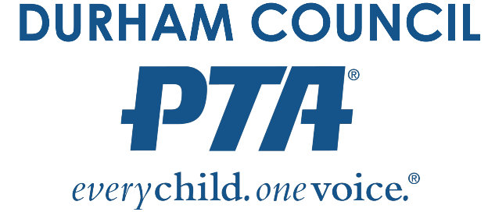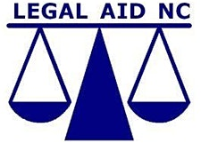

The City of Durham Eviction Diversion Program is a partnership between Legal Aid of North Carolina and the Duke Civil Justice Clinic to provide legal representation to low-wealth and low-income residents and families who are facing eviction. Every year, we assist hundreds of families threatened with or facing eviction (subject to restrictions).

